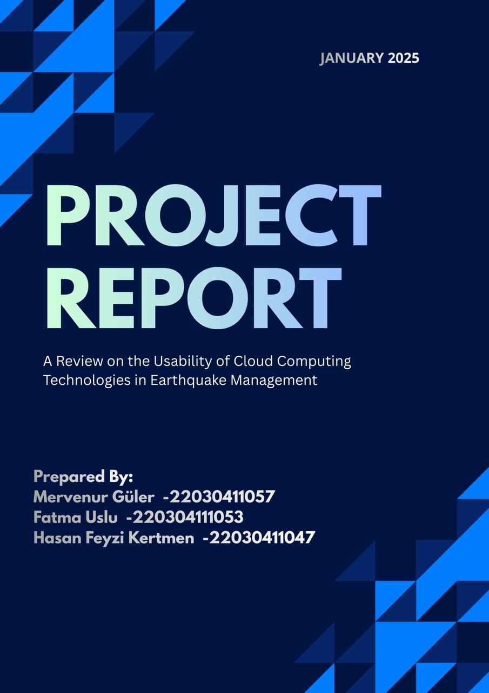
1- INTRODUCTION:

1.1- BACKGROUND:
Disaster management is a very important issue in our country. Because our country is an earthquake zone due to its location and geography. In our country, the earthquake risk is high and the destruction caused by earthquakes is significant. The frequency of earthquake events necessitates that we cope effectively with this situation. The difficulty in accessing information during earthquakes leads to people being misled. In our country, high levels of chaos often occur during earthquake moments. Information pollution and communication problems between institutions cause this process to progress worse. In this case, a solution is needed, and we believe that this solution lies in cloud systems. The role of cloud computing in disaster management has not been sufficiently examined, and we believe this issue should be given more attention.

1.2- CONTEXTUAL INFORMATION:
Cloud computing enables the storage, sharing, and processing of data. It reduces dependence on physical servers. Cloud computing enables easy access to data from anywhere. The data storage can be scaled according to needs, making it flexible. Allows simultaneous sharing of data.Cloud computing is the most suitable technology for systems to operate without failure during disasters and for multiple institutions to access the same data. Because quick decisions must be made during a disaster. This decision requires accurate and up-to-date information. Cloud computing assists in the collection and coordination of this data. Cloud computing is particularly worth exploring for earthquake management.

1.3- COMPARATIVE ANALYSIS:
Aspect | Existing Approaches | Proposed Solution
Focus Area | Earthquake response information is frequently managed through institution-specific systems with limited integration. | A research-driven, cloud-based disaster information-sharing and decision-support concept focused on earthquake management.
Technology Integration | Predominantly local/on-premise deployments and heterogeneous tools; scalability under peak demand may be constrained. | Cloud-native architecture enabling elastic capacity and service continuity during high-demand disaster periods.
Data Sharing | Inter-institutional data exchange may be ad-hoc and time-consuming; data silos are common. | Controlled cross-agency data sharing via centralized cloud services and standardized data interfaces.
System Resilience | Local infrastructure may be vulnerable to outages and performance degradation during disasters. | High-availability cloud infrastructure designed to reduce downtime and maintain access under stress conditions.
Decision Support | Decision-making may rely on partially available information and manual consolidation. | Consolidated cloud data environment supporting faster decision-making through unified dashboards and reporting.
Feasibility Demonstration | Limited experimentation with lightweight prototypes in academic contexts. | A web-based demo prototype to demonstrate feasibility and communicate the proposed approach to stakeholders.
Adaptability | Solutions may be tailored to specific agencies and are difficult to scale to other contexts. | Modular approach that can be adapted for additional institutions, data sources, and future research extensions.
Usability | Interfaces are often fragmented across institutions and may be complex for rapid use during emergencies; citizens may face delays in finding verified information. | Role-based, simplified dashboards for institutions and a clear citizen-facing information view to support fast access, low training effort, and consistent updates.

2- SCOPE OF THE PROJECT
The following aspects fall within the scope of the present study:
1- Earthquake-Focused Disaster Management Context:
Our project focuses on earthquake-related disaster management, including the information gathering and preparation phases.
2- Literature Review and Comparative Analysis:
To establish a conceptual foundation, international and Turkish academic sources will be reviewed.
3- Survey Study and Data Collection:
A survey will be designed and conducted regarding cloud system adoption, inter-organizational coordination, and disaster management challenges
4- Data Analysis and Interpretation:
The collected survey results will be analyzed to determine what is required for cloud-based disaster management.

5- Web-Based Demo Development (Feasibility Prototype):
A web-based demo system will be developed to demonstrate the proposed workflow, data sharing, and potential dashboards.
OUT OF SCOPE:
1- Other Disaster Types:
It should be noted that the project does not cover natural disasters other than earthquakes (e.g., floods, forest fires, etc.).
2- National-Scale System Integration:
It is important to note that full integration of national disaster management systems is not part of this project.
3- Commercial Product Development:
In this academic research project, the goal is not to develop a commercial product ready for use at the corporate level.
4- Live Early Warning Systems:
Real-time earthquake early warning systems are outside the scope of the project. The project's focus is on information management and coordination.
3- AİMS, OBJECTİVES AND SMART:
Aims:
In this project, we aim to make earthquake management easier.. We think that the use of a cloud system is appropriate for this.Therefore, we can say that this research is of great importance for Turkıye. In this project, we are investigating and analyzing how cloud computing can affect coordination and information flow in disasters.
Objectives:
In this research project, we will examine the existing work and identify areas that need improvement. We will also highlight existing good practices. We will examine the effects of cloud computing in earthquake management.The impact of cloud computing in disaster management will also be taken into account in other countries. This way, we will be able to see how cloud computing should or should not be in Turkey. At the same time, the survey data we collect will reveal what people and disaster management workers need. By evaluating the findings, we will ensure that the project's progress is on track.
SMART:
Specific:
This project involves research specific to earthquakes. It focuses on how this disaster can be managed using cloud computing.

Measurable:
This project will be supported by literature reviews, survey data, and comparative analyses. Our outputs will be in line with these results.

Achievable:
This project is accessible as an undergraduate research project. Additionally, the project's scope is highly realistic and the resources are sufficient.

Relevant:
Disaster management in Turkey has not sufficiently digitized. This situation is causing negative consequences.
Timed:
This project is scheduled to be completed in the project process.

4- WORK BREAKDOWN STRUCTURE:
Level 1 | Level 2
1. Project Management | 1.1 Defining the project initiation and research scope.  1.2 Sharing tasks within the team and planning weekly follow-up.  1.3 Documentation control and version management.
2. Literature Review | 2.1 Examining cloud computing concepts in disaster management  2.2 Examining examples of earthquake information systems and data sharing architectures  2.3 Investigating applications in this field.
3. Case Study Analysis | 3.1 Comparative analysis of cloud-based disaster management applications in selected countries (e.g., Japan and the USA)  3.2 Evaluation of its applicability to Türkiye.
4. Survey Design | 4.1 Creating a survey targeting disaster management experts, IT professionals, and public sector employees.  4.2 Pilot testing and final revision.
5. Data Collection | 5.1 Distribution of survey data via online platforms.  5.2 Completion of data collection and data set consolidation.
6. Data Analysis | 6.1 Interpretation of collected data using descriptive statistical methods (frequency, percentage, and mean values).  6.2 Comparative analysis between participant groups.
7. Demo Development (Feasibility) | 7.1 Development of a small-scale, web-based cloud demo system.  7.2 Testing of the developed system.
8. Reporting | 8.1Compilation of findings, evaluation of results.  8.2 Preparation of the final project report.

5- RACI MATRIX:
Project Step / Work Package | Mervenur  Güler | Hasan Feyzi Kertmen | Fatma Uslu | İhsan Tolga Medeni | Tunç Tolga Medeni
Project management & coordination | A | C | R | C | I
Literature review | A/R | I | R | C | I
Comparative case study analysis | A | R | R | C | I
Survey design (questionnaire + pilot) | A/R | R | R | C | I
Data collection (survey distribution) | R | C | A | C | I
Data analysis (quant + interpretation) | A/R | R | C | C | I
Demo development (feasibility prototype) | A/R | R | I | C | I
Reporting & final submission | A/R | C | C | C | I
Risk assessment + B plan + opportunities | C | A/R | I | C | I
Stakeholder assessment | C | A/R | I | C | I
Balanced scorecard | C | A/R | I | C | I

6- BUDGET & STAFF COST:

Project Title: Cloud-Based Earthquake Disaster Management Information Sharing System – Research and Feasibility Study
Agricultural Areas: A Study on Türkiye

1.Staff and Roles
Project Coordinator: Mervenur Güler
Researchers: Hasan Feyzi Kertmen, Fatma Uslu
Advisor: Prof. Dr. İhsan Tolga Medeni

Key responsibilities include
Conducting a literature review and comparative analysis, designing and implementing the survey.
Performing data analysis, developing a web-based demo prototype.
Preparing the final report.

Staff-Related Costs: No personnel salary is included. The budget reflects an academic research project and covers only direct research-related expenses.

2. Budget Breakdown
Budget Item | Estimated Cost (TL)
Transportation (meetings, stakeholder outreach) | 2,000
Services / Training / Courses (survey tools, training materials) | 5,500
Software Tools (demo development tools and basic subscriptions) | 1,000
TOTAL | 8,500

3. Observations and Recommendations
1.Personnel Expenses: Since the project is conducted in an academic research environment, personnel salaries are not included in the budget. The research is conducted on a voluntary basis. This approach ensures cost-effectiveness and financial transparency.
2. Cloud Computing and Digital Infrastructure Investments: The budget allocated for cloud services, software tools, and software-focused online training programs demonstrates the importance given to developing digital infrastructure and technical capacity.
3. Transportation Justification: The requested transportation budget is considered sufficient for conducting surveys, meetings, and potential face-to-face communication with disaster management and information technology experts.
4. Potential Deficiencies and Recommendations: The lack of an emergency budget may cause difficulties in the event of unexpected needs (e.g., changes in cloud service pricing or technical needs).
Future projects may consider allocating budget for additional training or workshops to increase corporate awareness and adoption of cloud-based disaster management solutions.

7.1- COST QUALITY TIME TRIANGLE:
1- Costs (Budget Constraints):
The total project budget is 8,500 TL. This money is for covering our needs such as cloud services and software tools, training programs, and transportation expenses. The TÜBİTAK 2209-A project budget is designed to help us achieve our goals without spending excessive amounts of money.
When considering the money to be spent, the main cost considerations are as follows:
• Cloud Services and Software Tools: We have a budget allocated for cloud services and software tools. This money will allow us to use cloud services and software tools, such as internet access and specialized programs, to create and test a demo system.
• Services: The project team will improve their skills by participating in training programs and certification courses on cloud computing and disaster management. This helps the team learn skills and become better at using technology.
• Transportation Expenses: We use the transportation budget to meet with people, conduct our surveys, and hold meetings with individuals interested in disaster management and computer systems. In this way, we can ensure everything runs smoothly with disaster management and information technology personnel.
• Risk Management: The budget is designed with priority given to cloud services, which are inexpensive and easily scalable. However, we anticipate that the cost of cloud services may fluctuate due to currency fluctuations, and this could be a problem for risk management, so we have planned to mitigate the impact of these changes.
• Financial allocation is essentially about how we use our money so that we can do everything we need to do with the money we have.

2- Quality (Deliverable Excellence):

Our project is crucial for the effective functioning of disaster and emergency management systems and aims to help meet their needs.
• Data-Driven Insights: When you look at data-driven insights from surveys and what people write about the issue, you arrive at logical conclusions. Data-driven insights are truly important because they are based on information, which makes them useful.
• Stakeholder Validation: When we receive feedback from people involved in disasters and experts working with computers, it helps us make our results more practical in real-world applications and ensure they are science-based.

• Technical Reliability: To see if our ideas actually work, we created a web demo system in the cloud and tested it to ensure its technical reliability. Developing and testing this system helps us validate our technical reliability results in a real-world environment.

3- Time (Project Timeline):
The project is planned to be completed in twelve months. We plan to do everything step-by-step, following an organized research plan. The project will be prepared by building upon each previous phase.
• Initial Phase (Months 1-4): Preparing the literature review, case study analysis, and survey design phases.
• Implementation Phase (Months 4-8): Conducting the survey, collecting data, and performing data analysis.
• Final Phase (Months 8-12): Developing and testing the demo system and preparing the final project report.
Our defined timeline ensures higher quality project outputs and allows us to achieve our desired results more effectively.

Conclusion
This TÜBİTAK 2209-A project allows us to prepare a realistic project timeline, with sufficient financial resources and academic rigor. Through cloud-based and systematic research, the project contributes to the development of disaster management systems and supports the transformation of emergency response processes to digital systems.

7.2- GANTT CHART:
The proposed project timeline is to be set for a period of six months. Moreover, there would be a sequential workflow of research. This involves: Literature and comparative analysis → survey → data analysis → demo on Feasibility → Reporting.
Work Package | Mar-26 | Apr-26 | May-26 | Jun-26 | Jul-26 | Aug-26 | Sep-26 | Oct-26 | Nov-26 | Dec-26 | Jan-27 | Feb-27 | Mar-27 | Deliverable
Literature Review |  |  |  |  |  |  |  |  |  |  |  |  |  | Reviewed sources + synthesis notes
Comparative Analysis (Japan/USA vs Türkiye) |  |  |  |  |  |  |  |  |  |  |  |  |  | Comparative gap analysis
Survey Design & Pilot |  |  |  |  |  |  |  |  |  |  |  |  |  | Final survey instrument
Survey Administration & Data Collection |  |  |  |  |  |  |  |  |  |  |  |  |  | Completed dataset
Data Cleaning & Data Analysis |  |  |  |  |  |  |  |  |  |  |  |  |  | Analysis results + insights
Web-based Feasibility Demo Development |  |  |  |  |  |  |  |  |  |  |  |  |  | Demo prototype
Final Reporting & Submission |  |  |  |  |  |  |  |  |  |  |  |  |  | Final report submission (Mar 2027)

7.3- TIME PLANNING:
1- Mar 2026: Project kick-off and planning for literature review and literature sources.
2- Apr 2026: Literature Review (Cloud Computing in Disaster or Earthquake Management).
3- May 2026: Research on comparative analysis, Japan and USA practices; data extraction
4- Jun 2026: Finalization of comparative gap analysis (Japan & USA &amp; Türkiye).
5- Jul 2026: Design and pilot test survey, and make necessary modifications based on pilot test results.
6- Aug 2026: Launch survey and controlled distribution, start reminder distribution.
7- Sep 2026: Continuing with collecting data pertinent to this study.
8- Oct 2026: Data cleaning and preparation; reliability and consistency checks.
9- Nov 2026: Analysis of data, and primary insights documented.
10- Dec 2026: Designing the demonstration of feasibility, flow, screen, and
11- Jan 2027: Beginning development of Demos for Feasibility (Web-based Prototype).
12-Feb. 2027: Reporting, editing, and finalizing the outputs.
Note: Final submission and any institutional presentation activities are planned for Mar 2027.
Key Milestones
End of Jun 2026: Literature review + comparative framework completed.
End of Sep 2026: Survey data is gathered and validated.
End of Nov 2026: Data analysis completed and results are interpreted.
End of Jan 2027: Feasibility demo prototype completed.
Mar 2027: Final Report Submission & Archiving.

8- RISK ASSESMENT:
Risk analysis was conducted using a probability/impact matrix. The probability categories are ranked from A (Rare) to E (Frequent), and the effects are measured in terms of impact categories that are ranked from 1, Minor, up to 5, Critical, depending on schedule, scope, and quality impacts. Risks that are low are not included, while others are logged.
Impact | Low | Medium | High
5
4
3
2
1
Figure 1. Risk Likelihood and Impact Assessment Matrix
Risk ID | Potential Risks | Likelihood (Low/Medium/High) | Impact (1–5) | Mitigation Strategies (B Plan)
R1 | Low survey participation / limited response rate | High | 4 | Use online distribution + reminders; target multiple stakeholder groups; keep survey short and anonymous.
R2 | Difficulty reaching key public-sector stakeholders | Medium | 4 | Leverage academic contacts; broaden sampling (academia + developers); document limitations transparently.
R3 | Time management slippage due to parallel coursework | Medium | 4 | Weekly checkpoints; lock scope early; focus on must-have deliverables; compress non-critical tasks.
R4 | Technical constraints during feasibility demo development | Medium | 3 | Simplify demo to core workflow; use lightweight prototype stack; prioritize feasibility over completeness.
R5 | Data quality issues (incomplete or biased responses) | Medium | 3 | Pilot test; apply cleaning rules; add screening questions; ensure neutral wording.
Owner: Hasan (Risk assessment, mitigation planning, and monitoring).

8.1- OPPORTUNITY ANALYSIS:
Opportunities were identified and assessed to increase the overall value of the research project. The same probability–impact approach was used to prioritize actions.
Opp. ID | Opportunity | Likelihood (Low/Medium/High) | Expected Benefit (Low/Medium/High) | Action / Expected Benefit
O1 | High stakeholder engagement enabling richer survey insights | Medium | High | Enhance outreach; optional short follow-up questions. Benefit: stronger recommendations and higher research validity.
O2 | Feasibility demo can be extended into a larger pilot proposal | Low | High | Exploit by documenting architecture + roadmap. Benefit: foundation for future academic/industry collaboration.
O3 | Potential academic dissemination (poster/paper/presentation) | Medium | Medium | Enhance by structuring results for publication. Benefit: academic visibility and portfolio value.

9-STAKEHOLDER ASSESMENT:
Stakeholder Assessment
1- Public Institutions (AFAD / municipalities / ministries)
Influence: High
Impact: High
Management Strategies:
Ensure Support for Data Gathering and Institutional Views.
Sharing intermediate results is important in order to ensure transparency.
Promoting cloud information sharing and interoperability during earthquakes2-Academicians and Researchers
Influence: Medium
Impact: High
Management Strategies:
Use peer review to validate the survey technique and results.
Help to Refine Comparative Analysis and Research Frameworks
Facilitate academic dissemination (presentation/poster/paper),
3- Funding Agencies (e.g., TÜBİTAK)
Influence: High
Impact: Medium
Management Strategies:
Provide milestone updates and document the outputs.
Emphasize the social significance and scalability of results from the proposed research work.
Maintain a clear budget justification for potential follow-up support.
4-Technology Developers (Cloud / Web)
Influence: High
Impact: High
Management Strategies:
Keep the lines of communication open regarding the constraints on feasibility and the resolution of problems.
Ensure that the demo focus remains on primary activities and optimizing processes.
Document assumptions about technical requirements to mitigate risks of project implementation.
5-Local Communities (Indirect Stakeholder)
Influence: Low
Impact: High
Management Strategies:
Reflect the needs of the citizens in the recommendations (Accessibility, Clarity, Trust).
Emergency response should prioritize the flow of good information and the mitigation of misinformation.
Think about usability of the demo story in non-technical contexts.

10- BALANCE SCORECARD:
Perspective | Objective | KPI | Target | Initiative
Financial | Maintain low-cost execution | Budget variance | ≤ 5% | Prioritize free/student tools; monitor expenses monthly.
Financial | Ensure spending supports deliverables | % costs linked to outputs | ≥ 90% | Map each expense to work packages and deliverables.
Financial | Reduce tooling cost risk | # paid tools avoided via alternatives | ≥ 2 | Use open-source/student tiers for survey and analysis tooling.
Customer | Increase stakeholder satisfaction | Stakeholder feedback score | ≥ 85% | Collect short feedback after interim results; refine recommendations.
Customer | Broaden stakeholder coverage | # stakeholder groups reached | ≥ 4 | Target outreach: public sector, academia, developers, support bodies.
Customer | Increase perceived usefulness | % respondents rating outputs actionable | ≥ 70% | Translate findings into clear recommendations and use-cases.
Internal Processes | Deliver milestones on time | On-time milestone rate | ≥ 90% | Weekly tracking; scope lock; clear task ownership.
Internal Processes | Run survey efficiently | Survey completion rate | ≥ 60% | Short survey; reminders; mobile-friendly distribution; pilot test.
Internal Processes | Ensure analysis quality | Data cleaning checklist completion | 100% | Define cleaning rules; document decisions; validate with pilot issues.
Internal Processes | Stabilize demo delivery | Demo test pass rate | ≥ 90% | Iterative testing; freeze scope before reporting month.
Learning & Growth | Strengthen cloud/disaster expertise | Learning hours per member | ≥ 12 hrs | Curated reading list; weekly mini-briefings; notes repository.
Learning & Growth | Improve research capability | # methods applied | 3 | Use literature + survey + comparative analysis; document methodology.
Learning & Growth | Enhance documentation skills | Report quality checklist | Completed | Template compliance checks; academic language consistency; proofreading.

